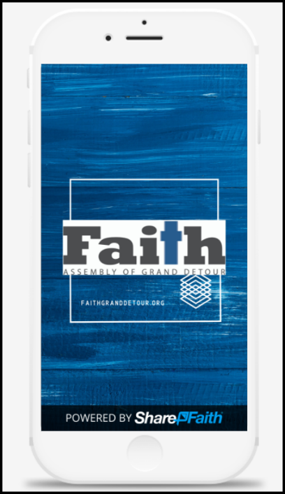
Welcome to the Faith App!

We are happy to announce our very own Faith app is now available for download. Easily add our app to your smartphone or tablet for easy digital access and to stay current on the latest.

Features include:
- Real-time push notifications when something new is added or announcements we need you to know about, found under “news & updates”
- Quick links to Sunday service registration and online giving
- Read Faith blogs or listen to Faith sermon podcasts right from your device
- Easy access to church calendar, Faith Kids resources, Foundation Youth page, and Faith YouTube channel
- Additional features will be added over time
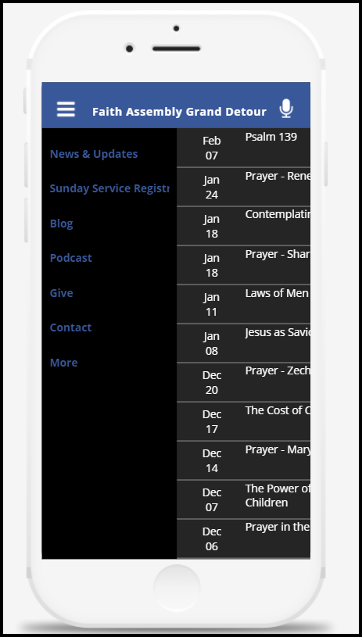
Here’s how to download:

- Go to the Google Play or Apple App store

- Search for the free “ShareFaith” app and download it to your device

- Once downloaded, tap to open and the church finding tool will appear

- Type in “Faith Assembly Grand Detour”

- When church name appears, tap it and click save

- When presented with the option between “my ministry” and “default”, choose “my ministry”

- Tap “allow” to receive notifications if you are presented with the option. You may have to allow them under your phone’s notification settings.

- The app may take a few minutes to load. Please note, you will see the Faith logo, but underneath it will say “Sharefaith App” – this is correct.

- Once loaded, you’re ready to explore. If you need further help, we’ve added a section on the website homepage with a tutorial video and direct app store link. FaithGrandDetour.org

